IST 263 Project Milestone 3 – Site Media
Name:
Description:
The idea of my website would be an intro guide for athletes who suffer from injuries or junior athletes trying to improve their ability up to senior or professional athlete. The website will contain information about how I recover from serious injuries and able to walk or run like before. Specific trainings and amount of time consumption, also includes some photos and videos for helping the understanding of the process.
URL to Images on Github:
Login to github.com and navigate to your images folder for the project. Copy the url and paste it here. | Images/projectphotos/AI_Generated_Image_2025-10-04_497300182029201.png  Images/projectphotos/Screenshot 2025-10-04 at 15.26.44.png  Images/projectphotos/Screenshot 2025-10-04 at 15.27.34.png  Images/projectphotos/chuttersnap-zL2BwKeROxM-unsplash.jpg  Images/projectphotos/debby-hudson-U-O9DCDI4E8-unsplash.jpg  Images/projectphotos/medical-cross_18067926.png  Images/projectphotos/omar-ramadan-A9XmmNGthbc-unsplash.jpg  Images/projectphotos/run-187758_1920.jpg  Images/projectphotos/tom-claes-AtWb4spCKHI-unsplash.jpg  Images/projectphotos/vitaly-gariev-gqcwbx29mvU-unsplash.jpg  Images/projectphotos/yury-kirillov-pbUWW-CBoqY-unsplash.jpg  Images/projectphotos/Bone-damage.png  Images/projectphotos/Leg-compression.png  Images/projectphotos/Muslce-damage.png  Images/projectphotos/First-aid-image.png

NOTE: You need to legally use all your images. The options for usage writes should be: I own this, creative commons, has been adequately transformed, free stock, or some other way you legally use the image. Embedded content gets the NA (not applicable).

Your turn! Enter your images below. FYI – the images you find need to be quite large to look good on your website. If the image you find is tiny, keep looking.
Media Thumbnails | Page | Usage Rights | Citation (if applicable)
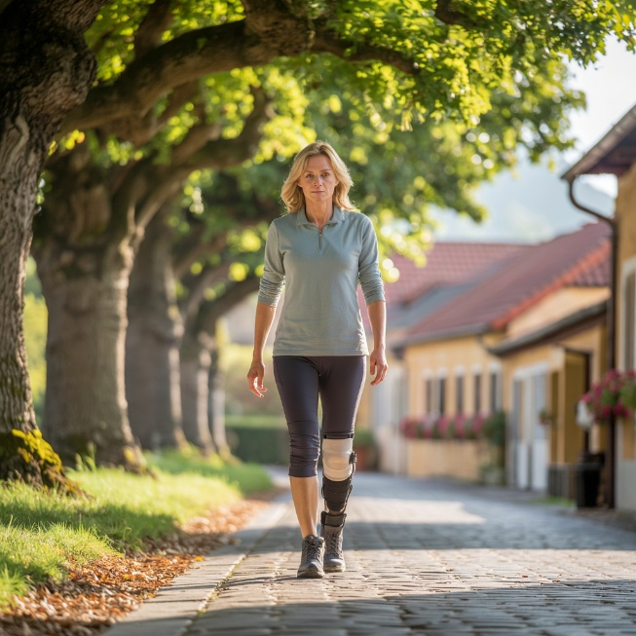 | Home Page | Image made with Canva | NA
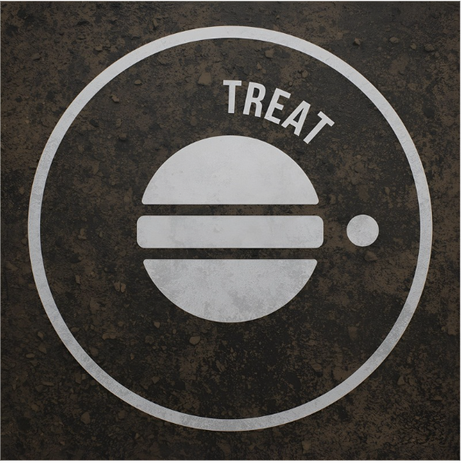 | Home page | Image made with Canva | NA
 | Home page | Image made with Canva | NA
 | Home page | Image made with Canva | NA
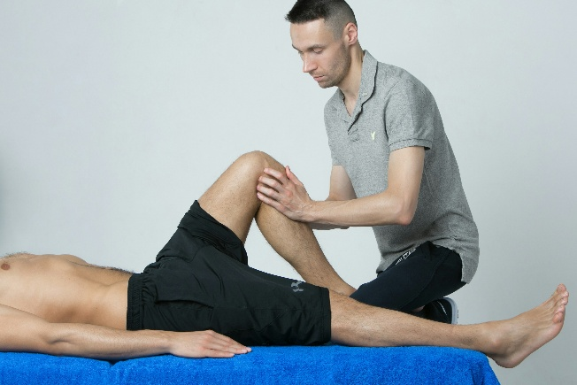 | Treatment guide | creative commons | Unsplash’syury kirillov
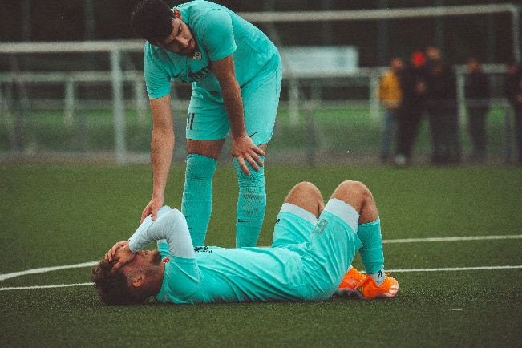 | Treatment guide | Creative commons | Unsplash’s Omar Ramadan
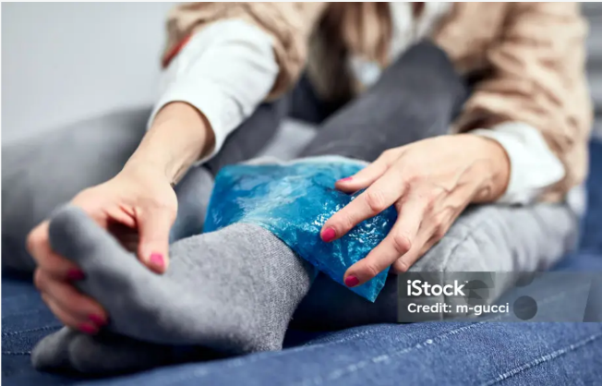 | Treatment guide | Creative commons | https://www.istockphoto.com/photo/woman-with-spasm-cramp-sprained-dislocated-ankle-ruptured-tendon-and-joint-pain-gm1349 013978-425788447
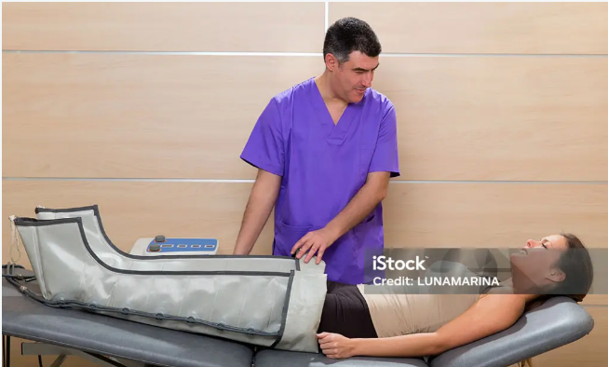 | Treatment guide | Creative commons | https://www.istockphoto.com/photo/doctor-checking-legs-pressotherapy-machine-on-woman-gm166184454-23659646?utm_source=pixabay&utm_medium=affiliate&utm_campaign=sponsored_image&utm_content=srp_topbanner-popular_media&utm_term=leg+compression
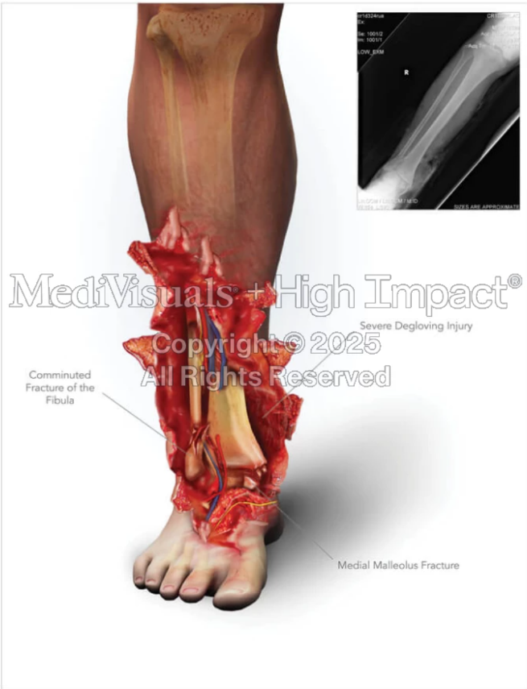 | Treatment guide | Creative Commons | https://www.highimpact.com/projects/summary-of-right-leg-injuries
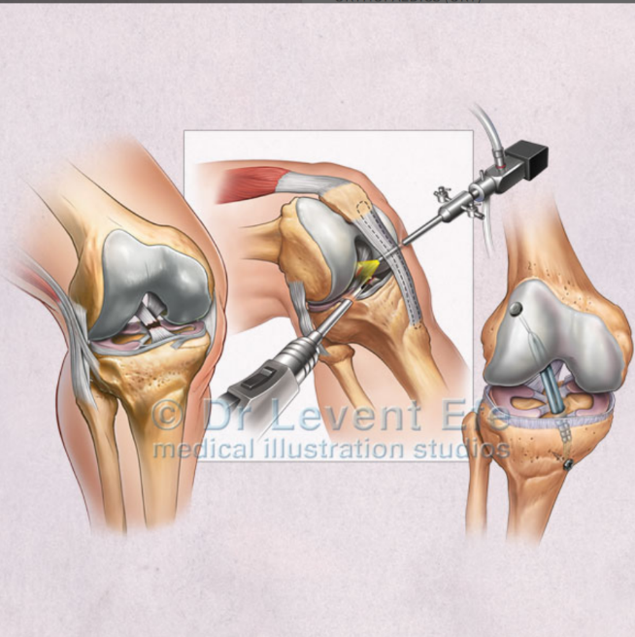 | Treatment guide | Creative Commons | https://www.medicalartbank.com/medical-illustration-shop/specialties/orthopaedics-ort/knee-arthroscopy-and-anterior-cruciate-ligament-repair/
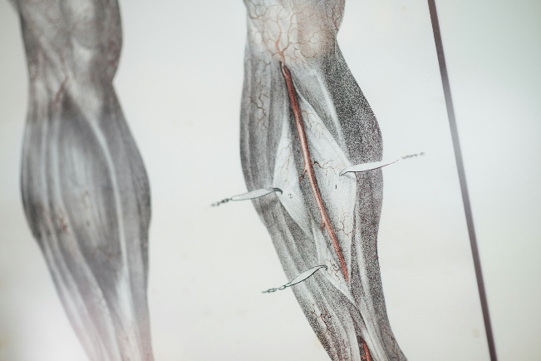 | Treatment guide | Creative Commons | Unsplash’sCHUTTERSNAP
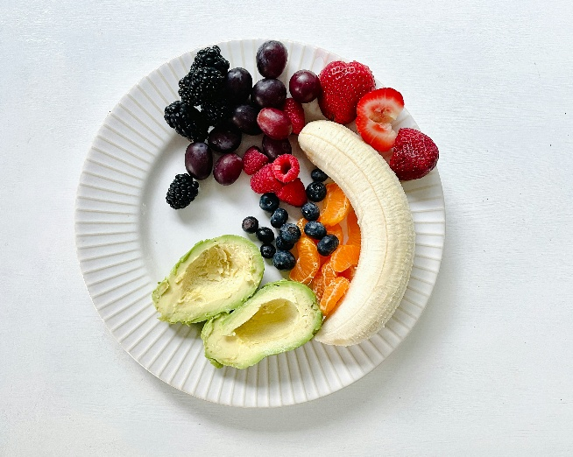 | Recovery & Lifestyle | Creative Commons | Unsplash’sDebby Hudson
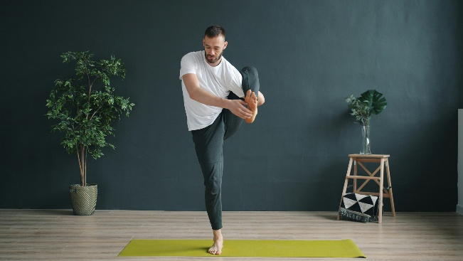 | Recovery & Lifestyle | Creative Commons | Unsplash’sVitaly Gariev
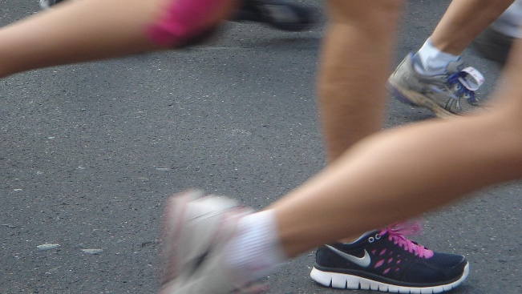 | Recovery & Lifestyle | Creative Commons | https://pixabay.com/photos/run-leg-health-human-187758/

